Main Workflow
- Triggered by Slack message.
- Parses the request (topic, platforms, email),
- Calls 2 sub-workflows in sequence:
- Info Research & Filtering (Phase 2)
- Newsletter Generation & Sending (Phase 4)
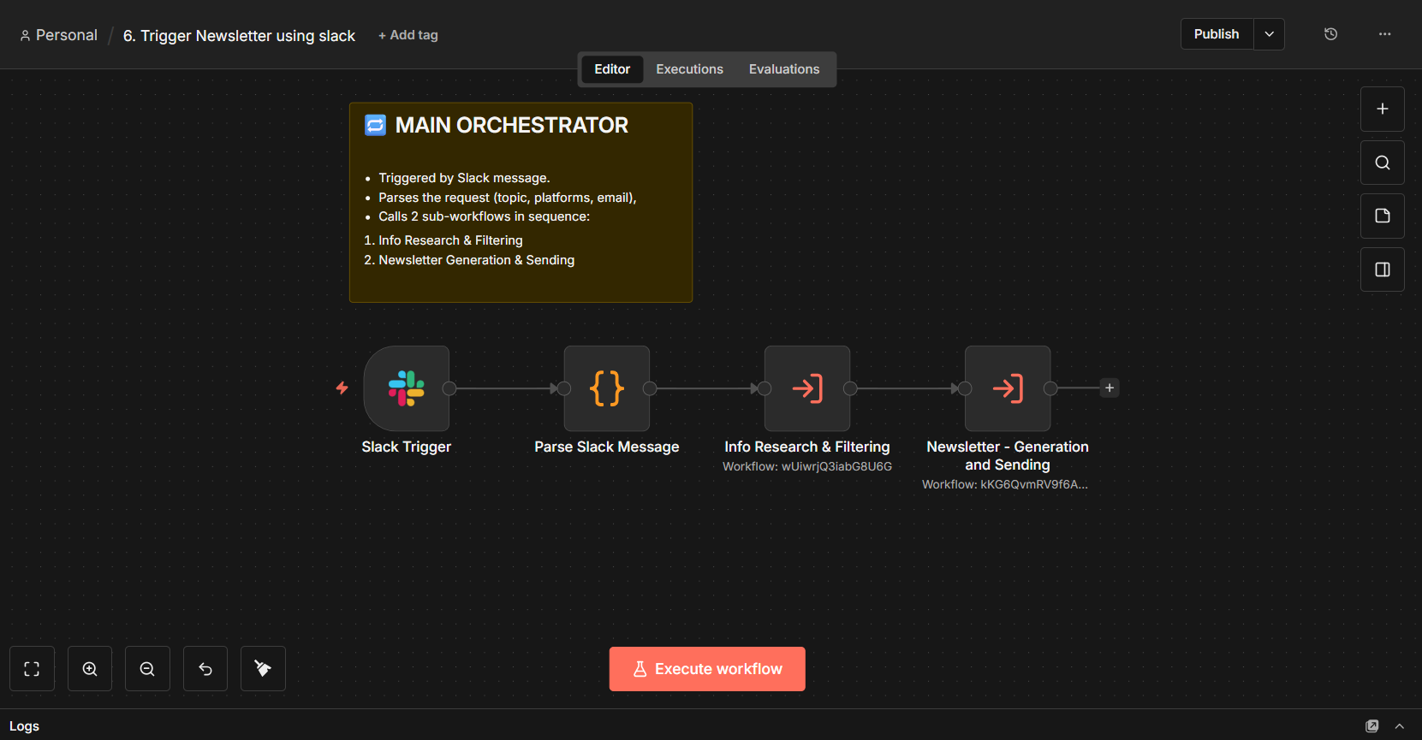

Sub-Workflow 1 — Info Research & Filtering
- Validates input fields
- Fetches fresh articles from NewsAPI
- Filters by
  - recency,
  - quality, and
  - removes duplicates
- Preserves original metadata
- Passes clean articles to Phase 4.

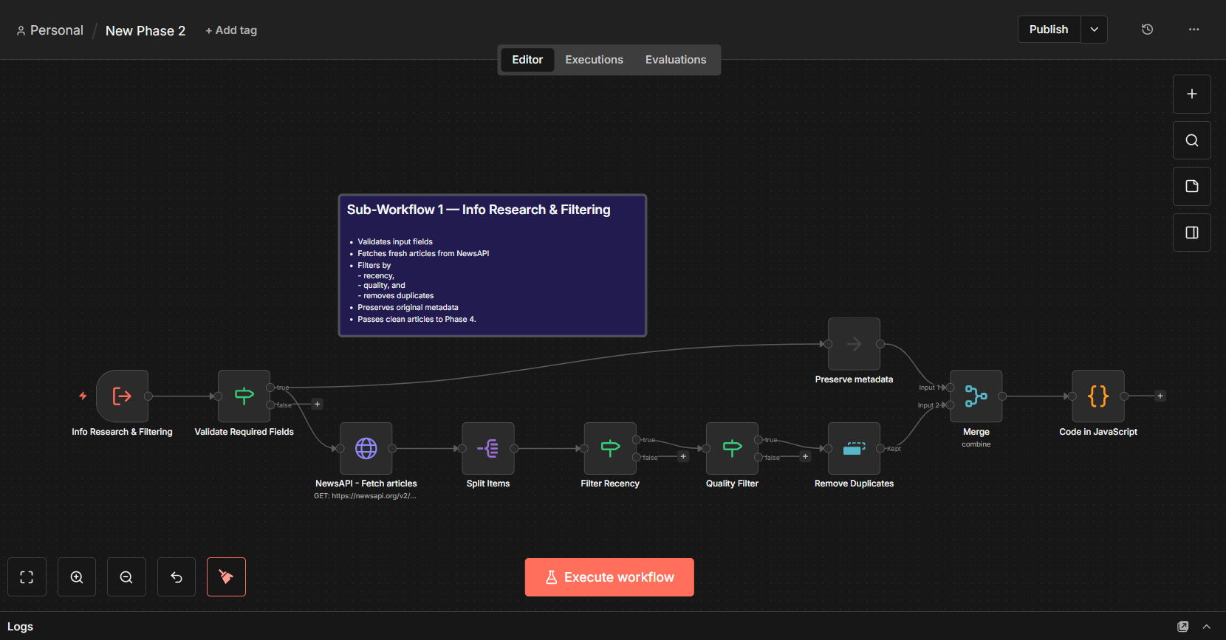

Sub-Workflow 2 — Newsletter Generation & Sending
- Takes filtered articles + topic from Phase 2.
- AI generates platform-specific content (email + Slack versions).
- JavaScript applies dynamic theming & design.
- PDFShift converts HTML → PDF attachment.
- Switch routes to correct platform:
  - Slack → post message in slack channel
  - Email → Gmail with PDF attachment
